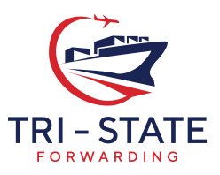

Client Agreement

I ,
authorize TRI STATE FORWARDING, INC. to charge my credit card,
Card Number , Expiration Date: , Security Code (3/4 Digit Number) ,
a total of US $ for the settlement of the following invoices.
I agree to an added charge of 2.95% for Visa/ MasterCard/ Discover or an added charge of 3.9% for American Express.
Signature ___________________________________________ Date

Please fill in your information as it appears on your credit card as well as the address to where the card bill will be mailed.
Name:
Street Address:
City, State, Zip Code:
Business phone or other phone associated with the account:

